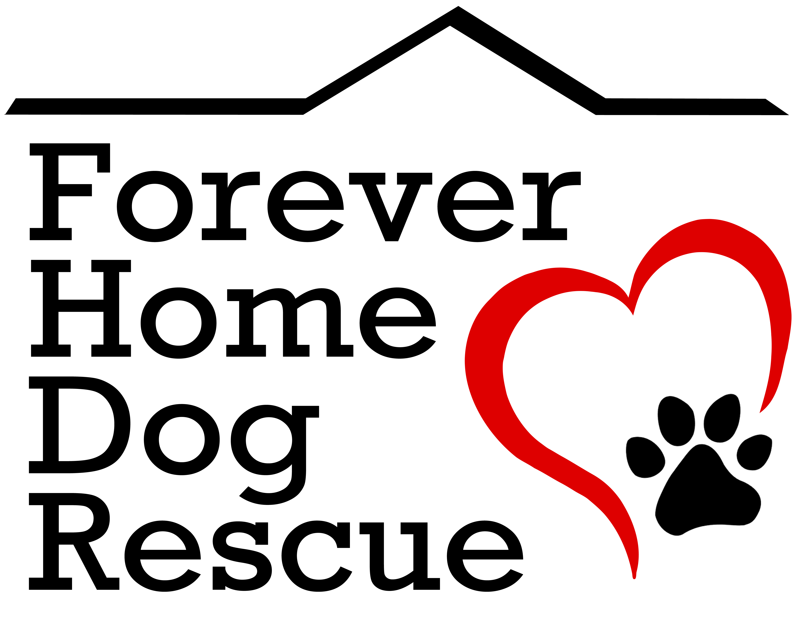Forever Home Dog Rescue
Foster Care Application

Please tell us about yourself:
Name: Date:
Address:
Daytime Phone # :______________ Evening or Cell Phone #: _____
Email: Birth Date:
Do you live in a: □ Single-family home □ Condo/Townhouse □ Apartment
Do you: □ Own □ Rent □ Live at relatives’ or friends’ house
If you do not own, please list
Property owner’s/landlord’s name:
Property owner's/landlord's phone:
Please tell us about your household members:
Name | Age | Name | Age

Current Pets: Please list all current pets.
Name | Breed | M/F | Spayed/Neutered | Vaccinated? | Kept In/Out
 |  |  | YES / NO
 |  |  | YES / NO
 |  |  | YES / NO
 |  |  | YES / NO
 |  |  | YES / NO

Who is your current veterinarian?
Phone:
Have you ever fostered before? YES / NO
Please provide three references we can contact if needed:
- Name/Phone #: __________ _____________________________________________________
- Name/Phone #: ________________________________________________
- Name/Phone #: ________________________________________________
What pet experience do you have?
_________________________________________
Please describe the area where your foster animal would be kept. For dogs/puppies, where will they sleep?
Please read the following statements about the Forever Home Dog Rescue Foster Program and initial next to them to indicate that you understand and agree to abide by them.

Your foster dog may not be house-trained and puppies can be messy. You understand he/she may have accidents in your home.
Like many dogs, your foster may chew on furniture, clothing, or other objects. You are comfortable working with this behavior. The foster home is responsible for any damage.
You agree to keep your foster dog on a leash, enclosed area or inside your home at all times.
You will NOT take your foster animal to a veterinarian or administer medications unless directed to do so by the Directors of FHDR. FHDR will not reimburse foster volunteers for any unapproved veterinary expenses.
FHDR may need to contact or visit you to discuss the foster dog. You agree to be entirely honest and forthright in regard to your foster pet’s condition, be it positive or negative.
There is some risk to your own animals, especially if your foster animals are not kept separate. You understand that FHDR is not responsible for your own pet’s medical treatment.
FHDR is the legal guardian of your foster dog. You understand FHDR has the final authority in regard to the animal’s adoption, treatment or disposition.
You will not leave your foster dog in the care of another person, including potential adopters, without approval.
As a foster parent in the Forever Home Dog Rescue Foster Program, you agree to care for your assigned dog for a minimum of one week. Based on the answers to your application, FHDR will choose the dog to be placed in your home. If you decide you want to adopt your foster dog, you will have priority.

By signing this form, you agree to the above statements and certify that the answers given above are true. Completion of this application does not guarantee acceptance into the Forever Home Dog Rescue Foster Program.

Signature: Date:
Please save your completed application and email to inquiries@fhdrwa.org
We will contact you shortly. Thank you!

